**HOLIDAY PACKAGE TERM III, 2023 BABY CLASS**

**GENERAL INSTRUCTIONS:**

**1. This Holiday package is composed of all subjects.**

**2. Each subject contains three covered topics of last term.**

**3. All work in each subject shall be marked out of 100mks.**

**4. Parents can assist their children in the project work.**

**5. Parents should ensure that children attempt all questions.**

**6. Diagrams must be drawn in pencils.**

**7. Parents should ensure that the Holiday package comes back when it’s clean.**

**8. Good handwriting will earn you an extra mark.**

**9. Parents should guide the pupils and not to write for them.**

**10. Holiday package shall be submitted in on the first day of Term one, 2024. Any work which will come after the first day shall not be received.**

**11. Holiday package will be counted in the continuous assessment.**

**12. Parents/children who meet any challenges should contact the school for assistance.**

**Name ___________________________________**

**Class : __________________________________**

**School :_________________________________**

**LEARNING AREA 4 – NUMBERS**

**1. Copy and write I – 20**

**I**

**3**

**2**

**5**

**I0**

**6**

**7**

**8**

**9**

**I5**

**I**

**I3**

**I2**

**I I**

**I6**

**I7**

**I8**

**I9**

**20**

**2. Match and write.**

I 5 _______

2 6 ________

3 I ________

2 ________

5 3 ________

6 ________

**3. Count and shade for the number.**

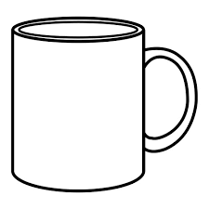 =

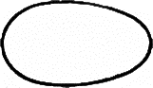     = 0

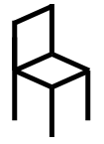 = 5

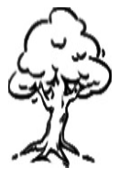 = 3

**4. Tick the different number.**

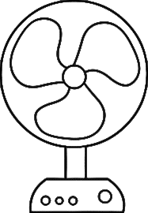  

**7**

**7**

**2**

**6**

**6**

**2**

**3**

**5. Match the same numbers.**

I I3

2 I9

3 I0

9

5 8

6 I I

7 20

8 I7

9 I2

I0 3

I I I

I2 2

I3 5

I

I5 8

I6 6

I7 7

I8 I

I9 I5

20 I6

**6. Fill in the missing number.**

2, ____, , _____, 6

____, 2 , ____, , _____, 6

**7. Draw balls for the number.**

|  |  |
| --- | --- |
| 7 |  |
| 9 |  |
| 6 |  |
| 5 |  |
| I0 |  |

**8. Copy the same.**

|  |  |  |  |  |
| --- | --- | --- | --- | --- |
|  |  |  |  |  |
|  |  |  |  |  |

**9. Draw for the number**

|  |  |
| --- | --- |
|  | = 2 |
|  | = 5 |
|  | = |
|  | = 3 |

**10. Add the numbers.**

2 + 3 = 5 _

6 + 2 = _______

5 + 3 = _______

+ 2 = _______

+ = _______

+ 6 = ________

**11. Read and circle.**

|  |  |
| --- | --- |
| one | 0 3 I |
| six | 6 2 |
| ten | I2 I0 I I |
| five | 5 I0 9 |

**12. Read and colour.**

 red 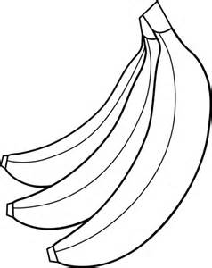 yellow

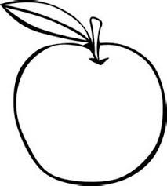 orange 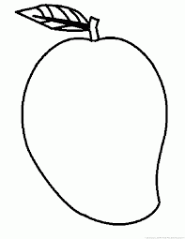 green

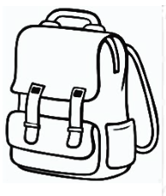 black 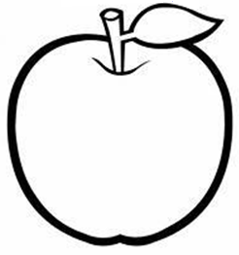 blue

**13. Draw balls on the string.**

= 6 = 7 = 5

= = 9 = I0

**14. Count and write.**

= _______ = _______

= _______ = _______

**15. Ring the odd man out.**

2 2 2

8 8

5 5 6

3 2 3

7 7

**16. Match the shapes.**

**17. Count and write**

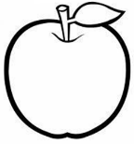 = __________

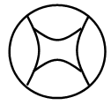 = _________

 = __________

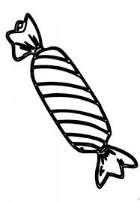 = __________

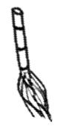 = __________

**18. Shade the shapes.**

**19. Form small sets from the big set.**

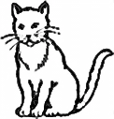

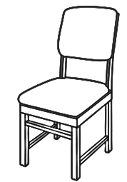

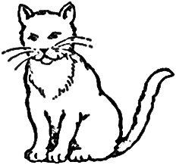









**20. Shade**



**LEARNING AREA 5 – LANGUAGE**

**1. Copy and write the letters a-z**

|  |  |  |  |  |  |  |  |  |  |
| --- | --- | --- | --- | --- | --- | --- | --- | --- | --- |
| a | b | c | d | e | f | g | h | i | j |
|  |  |  |  |  |  |  |  |  |  |
| k | l | m | n | o | p | q | r | s | t |
|  |  |  |  |  |  |  |  |  |  |
| u | v | w | x | y | z |
|  |  |  |  |  |  |

**2. Read and match the words.**

axe 

sun 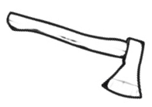

mat 

tree 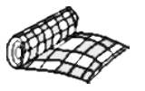

ball 

**3. Circle the correct word.**

boko book obok

cu puc cup

tree tere rh

**4. Read and draw.**

It is a bag It is a cup

It is a leaf I can see a book

This is a pen This is a flower

I can see a table

**5. Write the word for each number**

 5  3

tin

sun

hat

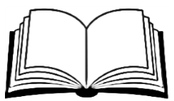2 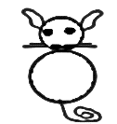 I 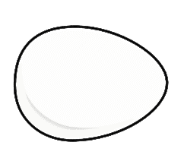 6

egg

cat

book

Number **I** is a ___________

Number  is a ___________

Number **6** is an ____________

Number **3** is a ____________

Number **2** is a ____________

**6. Fill in the missing sound**

a ____ c ____ d ____ e ____ ____ h ____

_____ k _____ m _____ o _____ _____

r _____ s _____ _____ w _____ y _____

**7. Write a word for the given letter.**

a = __________ m = __________

t = __________ b = __________

s = __________

**8. Circle the same and write the words**

gun on gun gun _

bed bed leg ___________

hoe leg leg ____________

jug axe jug ____________

ball under ball ____________

**9. Blend and form the word.**

m-e-n = ____________

g-a-p = ____________

t-a-p = ____________

c-u-p = ____________

i-s = _______________

h-a-s = ____________

t-a-g = ____________

**10. Make sentences.**

 This is a ______________

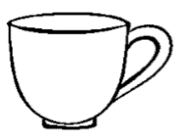 __________________________

 _________________________

 _________________________

 __________________________

( book ball mat cup box )

**11. Match the belongings.**

 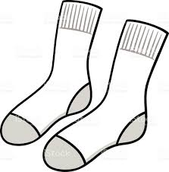

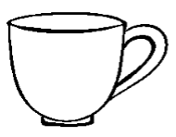 

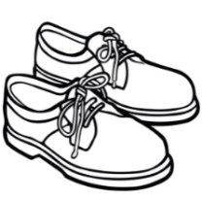 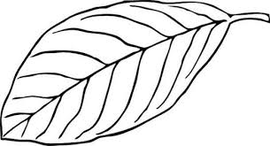

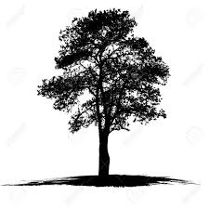 

**12. Shade people at home.**

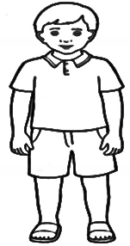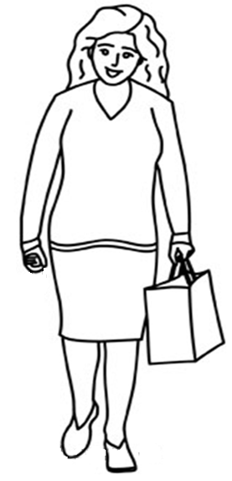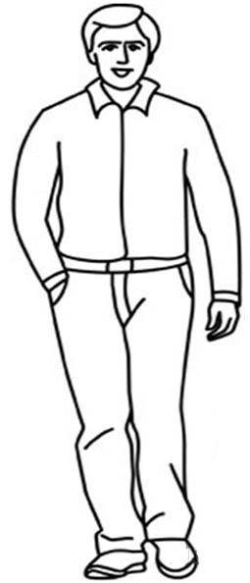

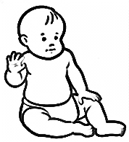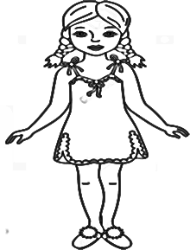

**13. Match the same pictures.**

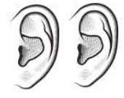 

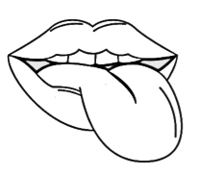 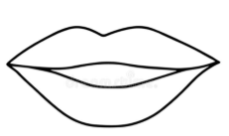

 

 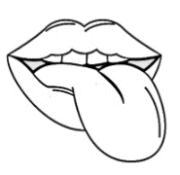

**14. Shade the fruits.**

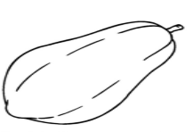 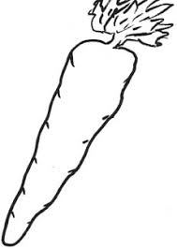

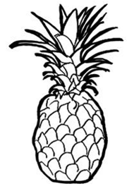 

**15. Name the important places (orally)**

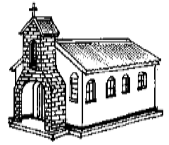  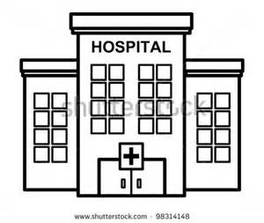

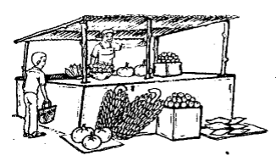 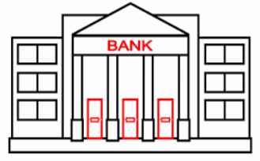

**16. Match the important places.**

 

 

 

 

**17. Shade.**

 

**18. Shade the colours and match.**

red 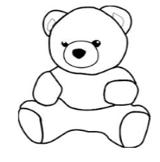 purple

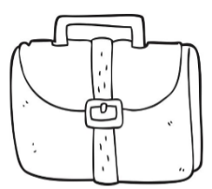 blue 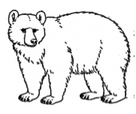green

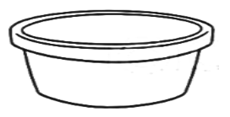pink red

yellow  blue

 purple pink

green yellow

**19. Fill in the missing letters.**

 tr ___ ___ 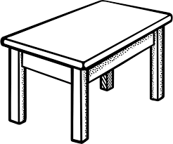 t___bl___

 br ___ ___m 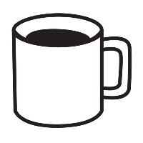 c____p

**20. Match and draw.**

  _________

  ________

  _________

  _________

**LEARNING AREA 2 – READING**

**1. Copy and write sounds a-z**

|  |  |  |  |  |  |  |  |  |  |
| --- | --- | --- | --- | --- | --- | --- | --- | --- | --- |
| a | b | c | d | e | f | g | h | i | j |
|  |  |  |  |  |  |  |  |  |  |
| k | l | m | n | o | p | q | r | s | t |
|  |  |  |  |  |  |  |  |  |  |
| u | v | w | x | y | z |
|  |  |  |  |  |  |

**2. Match vowel to the picture.**

a 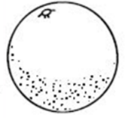

e 

i 

o 

u 

**3. Match vowel to the word.**

a on

e up

i egg

o in

u at

**4. Circle the same word.**

pen pen fan

hot zip hot

cat cat bat

tin cup cup

**6. Blend and read.**

f-a r-a k-a s-a m-a

n-a n-i z-i l-i v-i t-i

**7. Form the words.**

n-e-ddle __________ ti-n __________

li-p __________ ri-d __________

zi-p ___________ v-i-m __________

**8. Fill in the missing syllables.**

ba be bi bo bu

ta _____ ti _____ su

_____ de _____ do _____

ca _____ ce co _____

sa _____ _____ _____ _____

va _____ _____ _____ _____

ma me _____ _____ _____

ha _____ _____ _____ _____

pa _____ _____ _____ _____

_____ _____ _____ _____ ru

na _____ _____ _____ _____

**9. Tick(√) for the given picture**

|  |  |
| --- | --- |
| D:\All Drawings\Drawings\book.PNG | D:\All Drawings\Drawings\book.PNG D:\All Drawings\Drawings\ball 4.PNG D:\All Drawings\Drawings\leaf1.PNG |
| D:\All Drawings\Drawings\cup1.PNG | D:\All Drawings\Drawings\tin3.PNG D:\All Drawings\Drawings\pencil.PNG D:\All Drawings\Drawings\cup1.PNG |
| D:\All Drawings\Drawings\pot 5.PNG | D:\All Drawings\Drawings\chair0.PNG D:\All Drawings\Drawings\pot 5.PNG D:\All Drawings\Drawings\chair0.PNG |

**10. Write the five vowel sounds.**

_____ _____ _____ _____ ______

**11. Match and draw the pictures.**

book  _________

ball  _________

chair 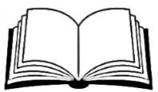 ________

moon  _________

star  _________

**12. Read and draw.**

That is a book

That is a bag

This is a broom

That is a car

That is a ball

That is a chair

**13. Copy the sounds and read.**

g p z n c b

_____ _____ _____ _____ _____ _____

e v m f d

_____ _____ _____ _____ _____

**14. Circle the correct word.**

|  |
| --- |
| hne hen nhe |
| bed bde dbe |
| teer eter tree |
| arm mra amr |
| tni tin nti |

**15. Match and write the same sounds.**

a d ________

c e ________

f b ________

b a ________

e c ________

d f ________

**16. Colour things found in class.**

  

**17. Copy and read these sounds.**

**m**

**______**

**p**

**______**

**______**

**c**

**c**

**______**

**______**

**f**

**h**

**______**

**______**

**j**

**b**

**______**

**______**

**b**

**LEARNING AREA 3 – GENERAL KNOWLEDGE**

**1. Name the things we use to clean our body (orally)**

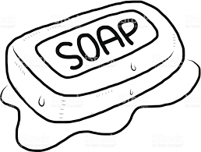 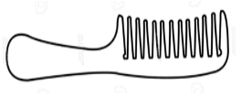

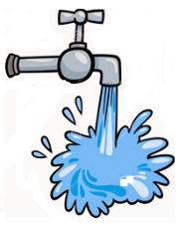 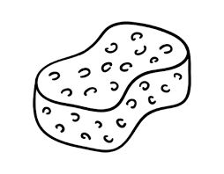 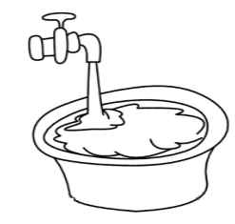

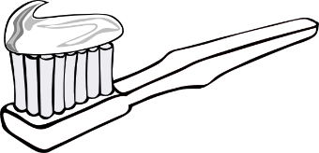

**2. Shade**

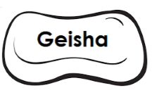

**3. Match the same body parts.**

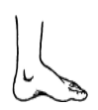 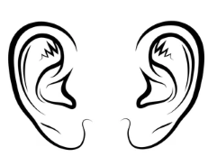

 

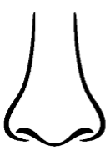 

 

**4. Circle the different body part.**

  

  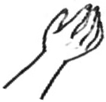

  

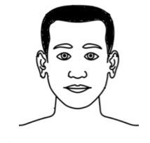  

**5. Match the same.**

 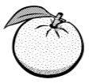

 

 

**6. Trace**

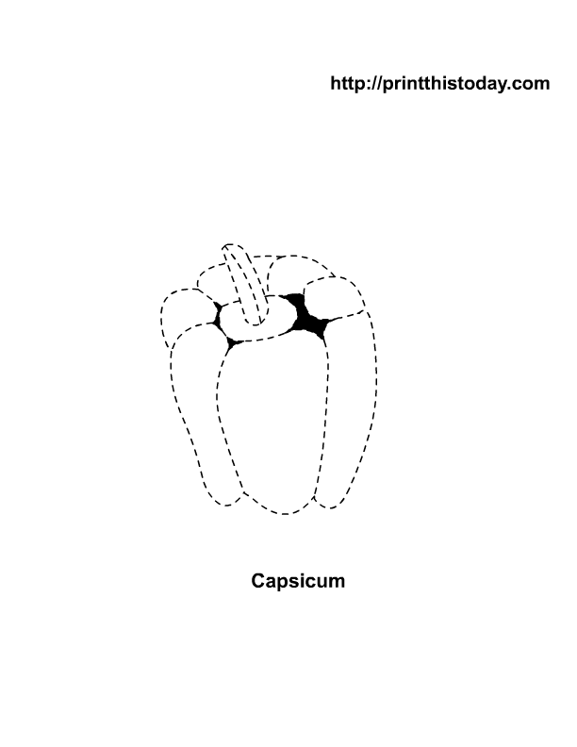

**7. Circle the given picture.**

|  |  |
| --- | --- |
| D:\All Drawings\Drawings\nail.PNG | D:\All Drawings\Drawings\nail.PNG D:\All Drawings\Drawings\broken bottle1.PNG |
| D:\All Drawings\Drawings\needle 1.PNG | D:\All Drawings\Drawings\nail.PNG D:\All Drawings\Drawings\needle 1.PNG |
| D:\All Drawings\Drawings\razorblade.PNG | D:\All Drawings\Drawings\broken bottle1.PNG D:\All Drawings\Drawings\razorblade.PNG |

**8. Shade these dangerous objects.**

 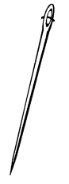

**9. Match the same important places.**

 

 

 

**WRITING**

**1. Copy and write**

|  |
| --- |
| **a e i o u** |
|  |
|  |

|  |
| --- |
|  |
|  |
|  |

|  |
| --- |
| **ant ant ant** |
|  |
|  |

|  |
| --- |
|  |
|  |
|  |

|  |
| --- |
|  |
|  |
| **egg egg egg** |

|  |
| --- |
|  |
|  |
|  |

**ink ink ink**

|  |
| --- |
|  |
|  |
|  |

|  |
| --- |
|  |
|  |
|  |

**orange orange**

|  |
| --- |
|  |
|  |
|  |

|  |
| --- |
|  |
|  |
|  |

**DRAWING AND SHADING**

**1. Draw the same**



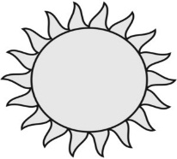



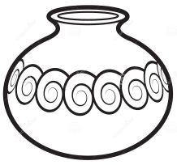



**2. Shade**

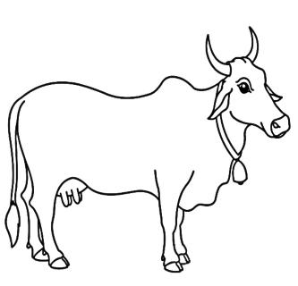

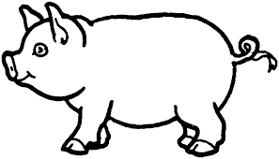

**\*\*\*\*\*\*END\*\*\*\*\*\*\***

**NICE HOLIDAYS**

**MERRY CHRISTMAS & A HAPPY NEW YEAR**

**HEBREWS 12:28-29**

|  |  |
| --- | --- |
| **Date** |  |
| **Parent’s**  **comment** |  |
| **Contact** |  |
| **Signature** |  |